M3d User Guide

The Interface
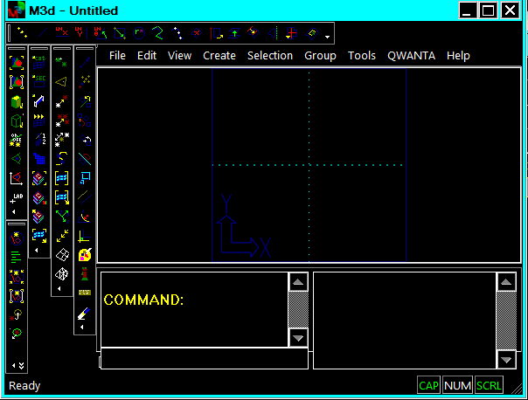
View area
Command line input
Toolbars
List area
Command window
Workplain

Command Line : Functions can be accessed by entering a command keyword in the command line. The command window will then prompt for the required information to complete the task. All commands in m3d have a keyword. Text file scripts of command maybe cut and paste into the command line.

Toolbars : Most commands associated with a keyword can also be invoked with an icon button in a toolbar.

List Window : Information and status is listed here.

View Area : the model is displayed in the view area. This can be dynamically paned, zoomed and rotated.
Pan - hold down the F1 button and move the mouse across the viewing area in the direction of panning,
Zoom - hold down the F2 button and move the mouse across the viewing . Moving the mouse down causes the model to zoom in, mouse up causes the model to zoom out.
Rotate - hold down the F3 button and move the mouse across the viewing area. Moving the mouse down causes the model to rotate in x ,moving the mouse across the screen causes the model to rotate in y.

Note when models are opened the screen does not auto zoom - so you will need to zoom out to find the model, if not in the view area

To set the rotation center select the following icaon

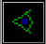
and pick an item from the screen.

Workplain : All coordinates are relative to the workplain. The workplain can be moved, realigned and set to a cylindrical coordinate system.

Mouse Buttons
Left Mouse Button (LMB) : Clicking this in the viewing area will cause items to be selected (assuming their not being filtered out). Clicking keeping the mouse button down and dragging out a box will cause all items inside the box to be selected.

Right Mouse Button (RMB) : Causes the following menu to be displayed. These menu items are used in-conjunction with the commands.
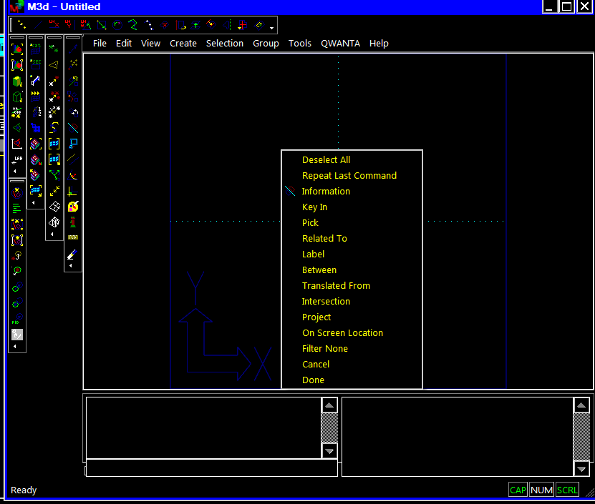

Most importantly in this menu are the "Cancel" and "Done" command which terminate the active command.

3) Points Creation
To create a point in the command line type "PTCR" you will then be prompted for the location. In the command line enter the point location in X Y and Z coordinates separating each ordinate by a space or comma (for example 1,2,3 or 1 2 3). The point will appear in the view area as shown below.

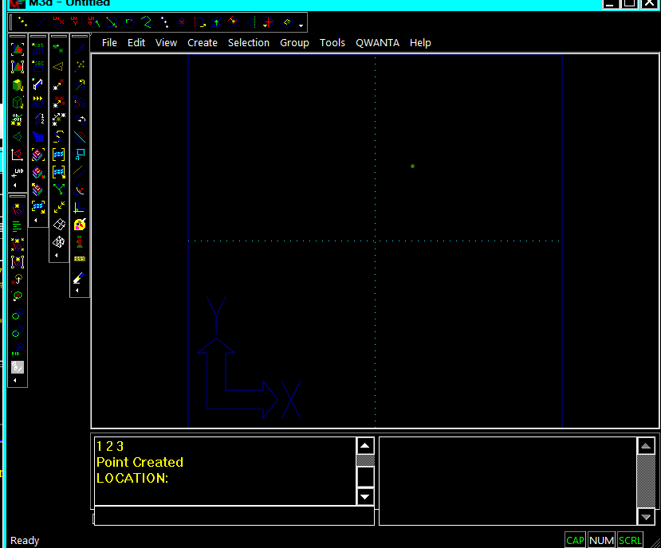

Note: the command is recursive and will repeat until terminated with a right mouse button "Cancel" command (RMB Cancel) or typing "C" in command line. This command "PTCR" can also be invoked from the "Create" toolbar button :-
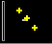

Creating a translated point from an existing point
Type "PTCR" and enter point location 1,2,3 as above. Next, from the right mouse button menu select "Translated From" (RMB Translated From).
You will then be prompted for a location for the point to be translated from. Select the point peviously created or type in the coordinate:-
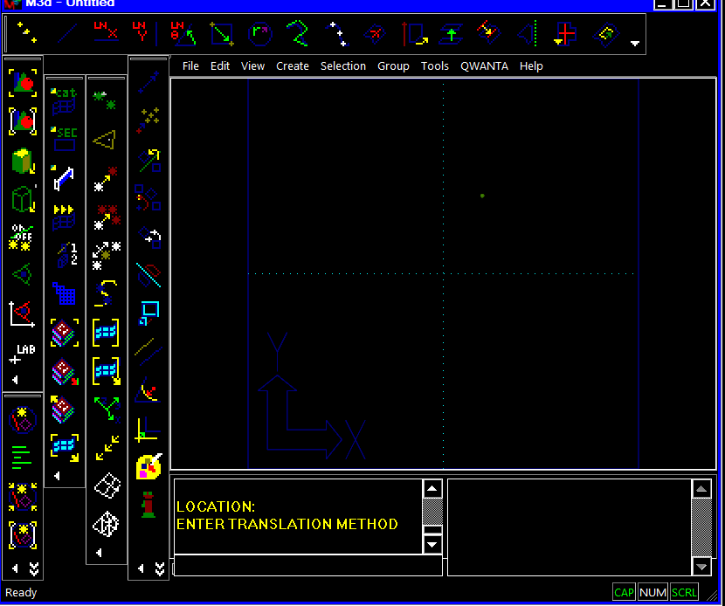

You will then be prompted for a translation method this can be (RMB Pick) or (RMB Key In). If (RMB Pick) is selected the translation vector is to picked from the screen and for (RMB Key In) the translation vector is typed in the command line. Select (RMB Key In) and type 1,0,0 in the command line, the new point should be displayed as illustrated below:-
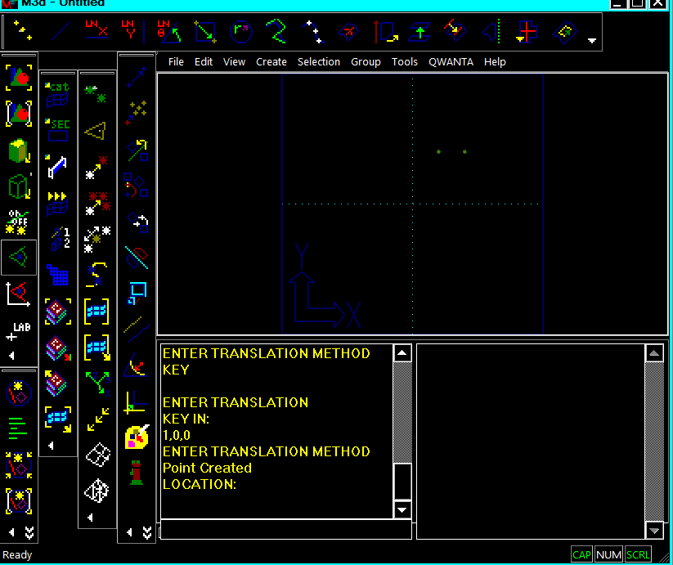

Creating a point between existing points
While still in the point create command select (RMB Between). You will then be prompted to select or enter two point locations. Pick the two points already created and a new point will be created between the two selected points as illustrated below:-
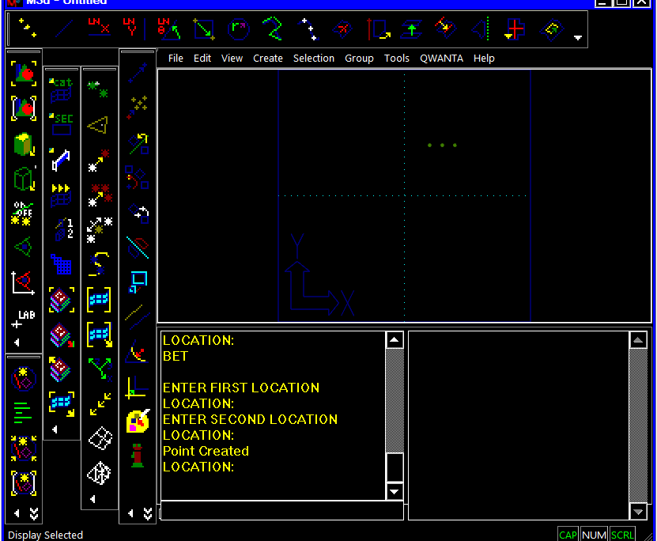

These commands can be chained together so you could create a point translated from a point between to others - etc.

Remember to (RMB Cancel) or type "C" in the command line to exit the points creation command.

Creating a Line
Type "LN" in the command line or select the following icon from the create toolbar
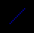
You will then be prompted for two point locations these can be selected from existing items on the screen or entered in the command line.
Enter 1,0,0 for the first point
Enter 3,3,0 for the second
The following line should be created:-
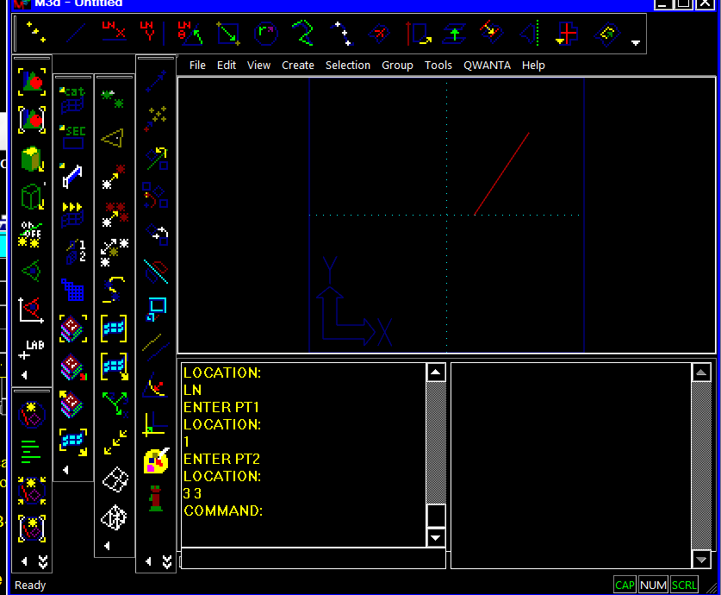

Creating a Rectangle
Type "RECT" in the command line or select the following icon from the create toolbar
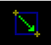
You will then be prompted for two point locations these can be selected from existing items on the screen or entered in the command line.
Enter 1,1,0 for the first corner
Enter 3,3,0 for the second corner
The following rectangle should be created:-
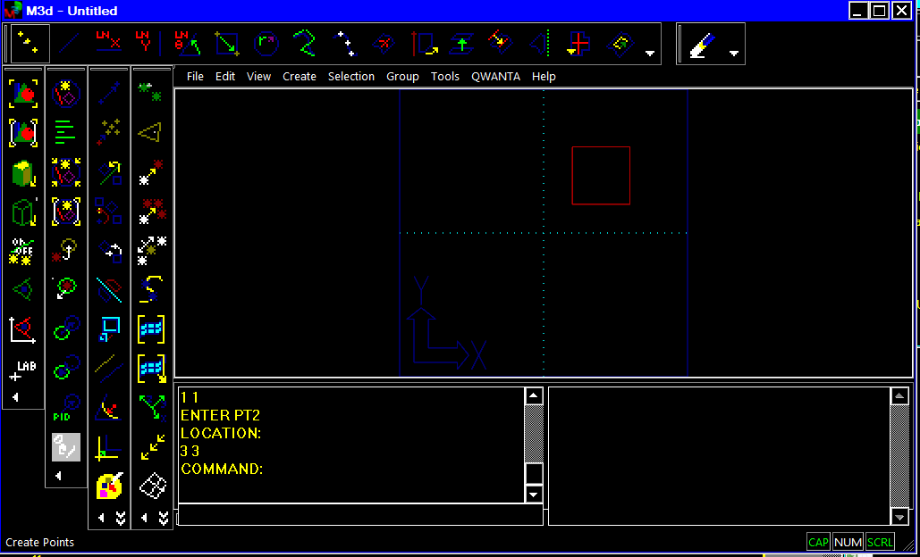

to sweep this rectangle about the Y axis select the sweep icon
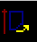
or type "SURRV" on the command line.
Select the curves by dragging a box over them, from top left to bott0m right, and click the middle mouse button or right mouse button menu "Done".
The following surfaces should be created:-
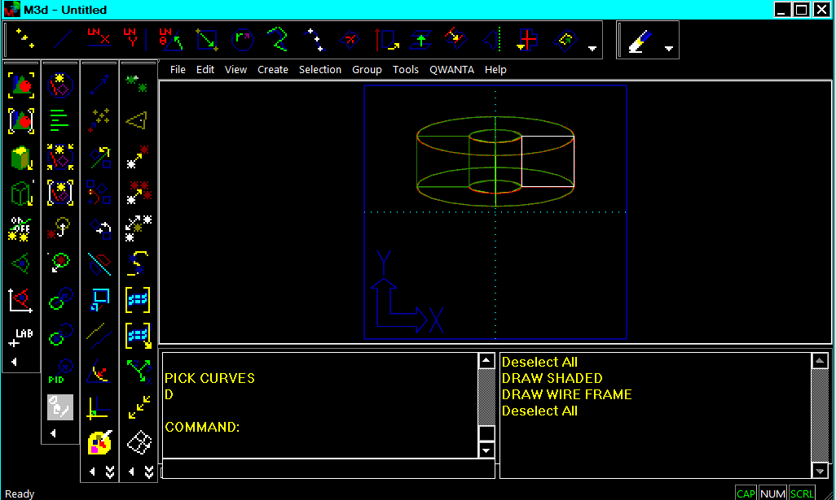

Note to pick an approximate point from the screen under the right mouse button select "On Screen Location" this picks a point projected to the work plain where the mouse was clicked. This works for all commands requiring a point location.

Creating a Lofted Surface
Type "SURCR" in the command line or select the following icon from the create toolbar
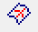
Select the cross section curve to loft a surface between
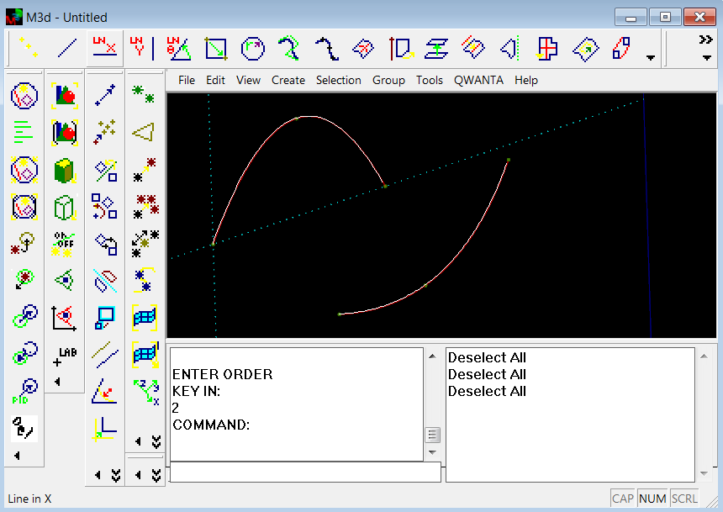
Note: Curves must have the same no of control point and order
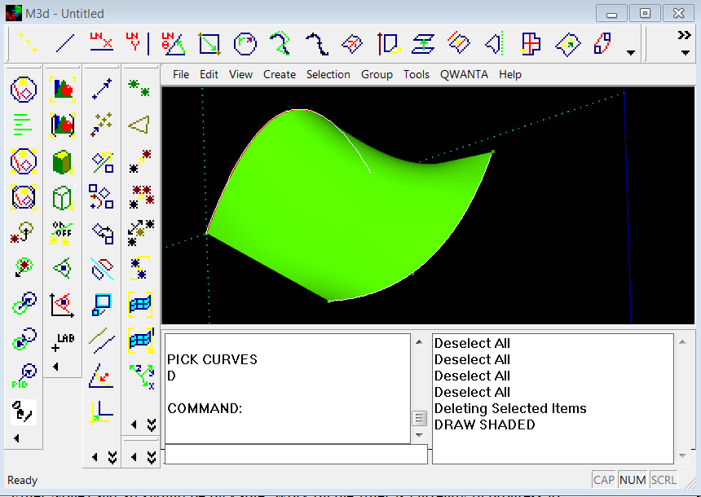

The Filter - IMPORTANT NOTE
The filter defines which type of objects are pickable on the screen, only items in the filter are selectable.
Important - note
Some commands set the filter so you can only pick the correct type of entity for the command. At present the some command leave the filter set on completion and this means you can find yourself unable to pick other entities. To clear the filter (RMB Filter None) and all should be pickable. Work on the filter is currently in progress to add a item selectable dialog box.

Display
All items in M3d are selectable, to display part of a model drag a box over the items to be displayed as illustrated below:-
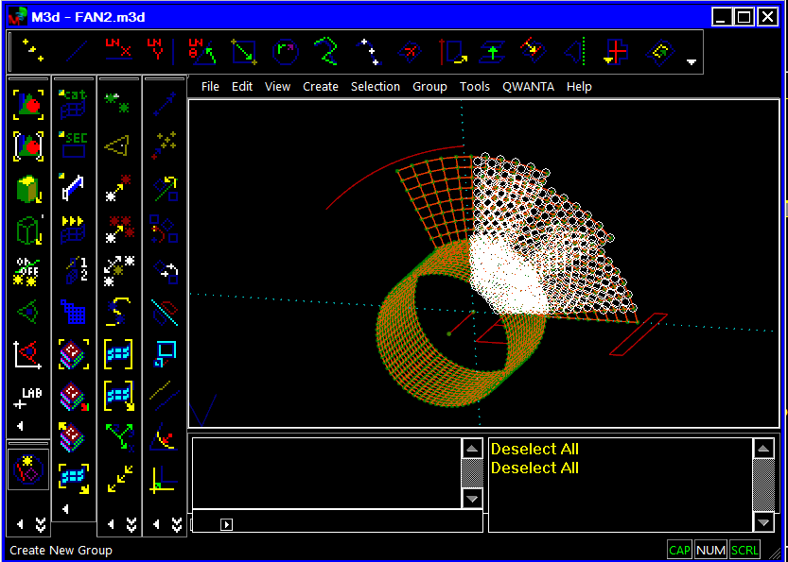
and press the display select icon in the view toolbar
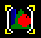
this will display just the selected items as shown below:-
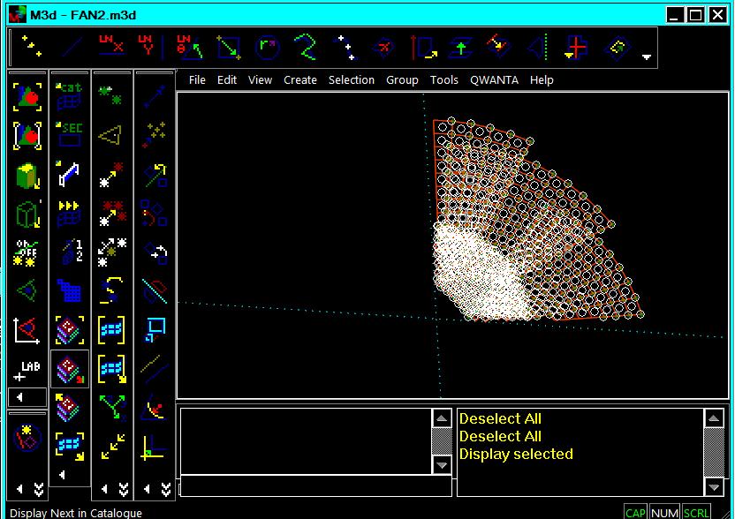
To deselect the items (RMB Deselect All)

To display the whole model again select the display all icon from the view toolbar
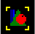

The Current Mesh
Note : M3d retains finite element meshes as separate objects. The M3d session can contain more than 1 finite element mesh. The picture below shows an assembly of 3 meshes and one of them is selected.
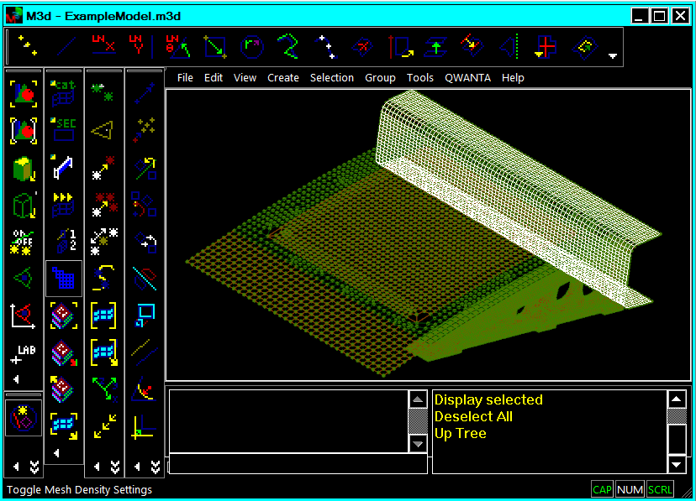
to select a mesh - pick one of the nodes or elements and then double click to walk up the hierarchy to select the mesh.

Important : to work on a particular mesh it must be set as the active mesh. To set the mesh as the current active mesh with it selected press the set current mesh icon on the FE toolbar.
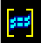
All nodes and elements created are entered into the current mesh.

To roll all the individual meshes into one assembly mesh select all the meshes to be combined. Then select "Create->Mesh->Build Assembly Mesh" this will build a final model and set it as the active mesh.

To create a material select Create->Material->Isentropic from the menu and follow the prompts.

To create a property select Create->Property->Shell Isentropic from the menu and follow the prompts.

To assign a property to elements select Tools->Element Modify ->PID then select the elements to modify and enter the PID.

This Document is in progress

Appendix A
Some of the command line keywords:-
CIRCR Circle centre radius
COL Change colour
COLINE Cordinate systems normal to element
COORDCR Cordinate system
COPY Copy items
CORNER Make corner
CVCR Create spline
CVFIT Create fitted spline
CVMOW Change weight of a nurbs control pt
CVONSUR Project curve to surface
CVPTON Points on curve
ELAT
ELCR Element create
ELMOPID Change element PID
ELTYPE Change element creation type
FCR Create force
FIL Item filter
FILALL Filter all
FILCLR Filter clear
FILET Filet
FILSET Set filter
GPADD Add to group
GPADDGP Add group to group
GPBYCOL Group by colour
GPBYPID Group by PID
GPCR Create new group
GPDSP Display group
GPLIST List group
GPREM Remove from group
GPREMGP Remove group from group
GPSET Set active group
LAB Select by label
LISTPROP List property
LMEAS Linear measure
LN Line
LNANG Line point and angle
LNX Line in WP X
LNY Line in WP Y
LNZ Line in WP Z
MOVE Move Items
NDBET Node between other nodes
NDCO Node copy
NDMOOSYS Node modify coordinate system
NDMOVE Move node
NDONCV Nodes on curve
OFFSET Offset lines
PTCR Create point
RCR Create restraint
RECT Rectange
RELTO Select items related to others
SELALL Select all
SELBYCOL Select elements by colour
SELBYMID Select elements with this material
SELBYPID Select elements by PID
SELBYTYPE Select elements by type
SELNODESBYCOL Select nodes by colour
SURBOUND Surface by boundaries
SURCR Loft Surface
SUREX Create surface by extruding curves
SURRV Create surface by revolving curves
SURTRIM Trim surface
SURTRIMLOOP Internal trim loop
TEST
WPALIGN Align work plain
WPGLOB Work plain to global
WPMODE Toggle work plain rectangular or cylindrical
WPSIZE Work plain size

